Client Handbook

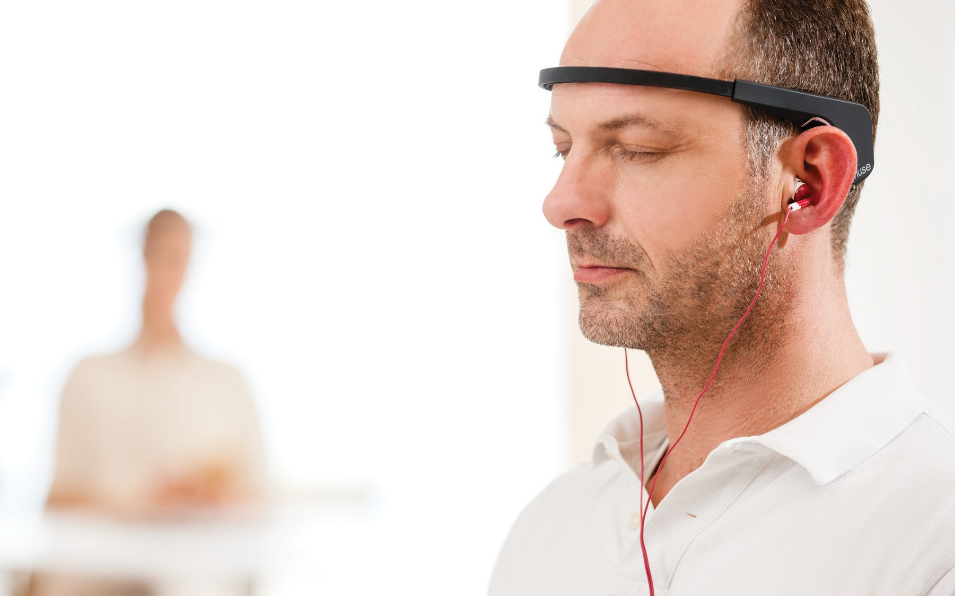
Meditation Made Easy™

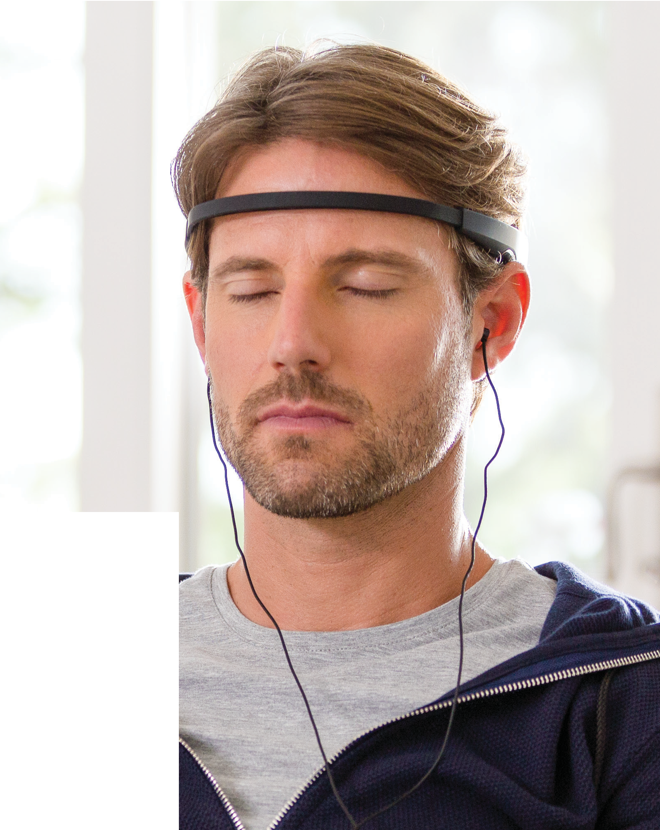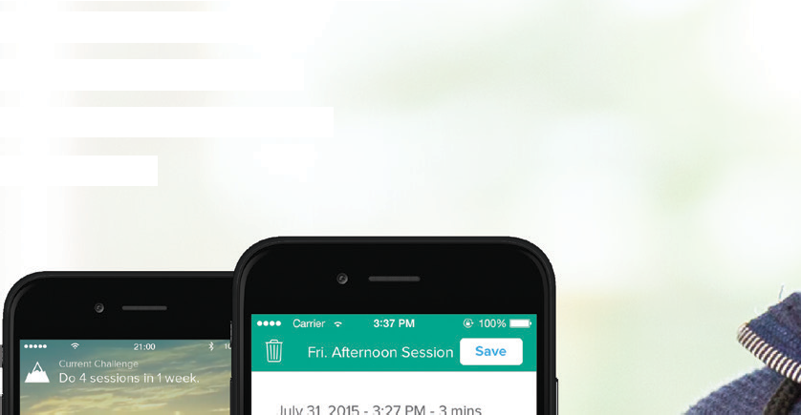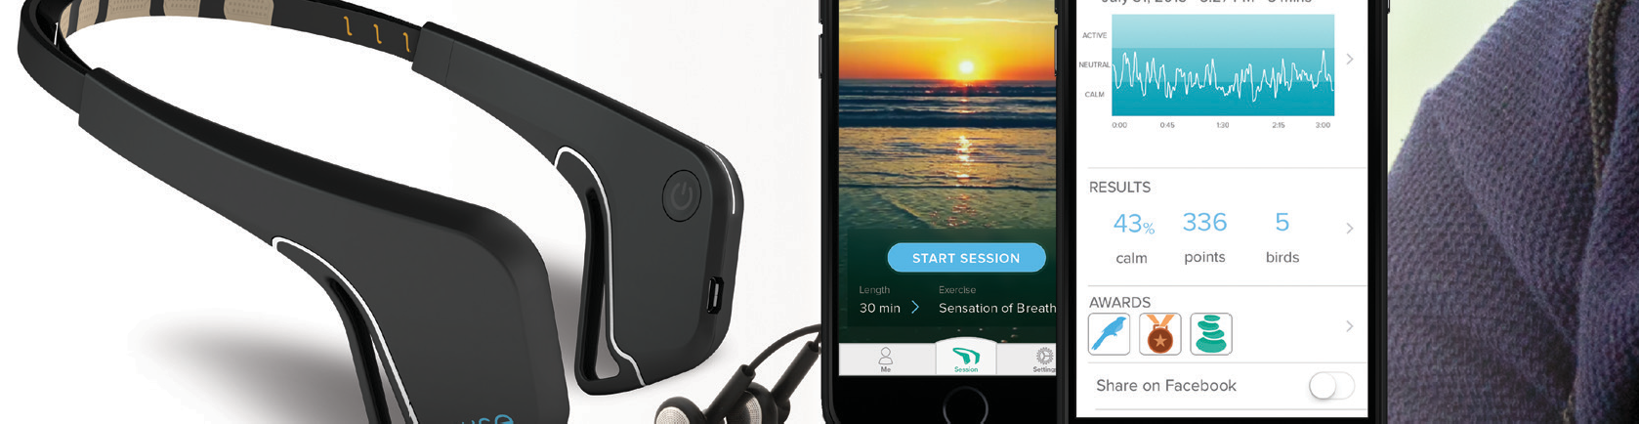

Muse Makes Meditation Easier

Meditation has many scientifically-proven benefits including reducing stress, anxiety, promoting better sleep, increasing focus, improving productivity, and emotional self-regulation. Muse: The brain sensing headband is a personal meditation assistant that can help take your meditation practice to new heights. The Muse meditation experience gives you accurate, real-time feedback on what’s happening in your brain while you meditate.

Muse can help teach you the essentials of focused attention meditation, rewarding you for consistent practice, and encouraging you to continue and build upon your meditation practice. Muse is there to help you keep motivated, and to help you get back on track when you falter.

Muse is more than a meditation app, it’s your personal assistant, who is there with you every step of the way, showing you how you’re doing, and helping you understand what’s happening while you’re meditating. Muse gives you the feedback you need to maintain a consistent meditation practice. Most of all, the Muse Meditation experience teaches you how to be present.
you’re doing, and helping you understand what’s happening
while you’re meditating. Muse gives you the feedback you need
to maintain a consistent meditation practice. Most of all, the Muse
Meditation experience teaches you how to be present.

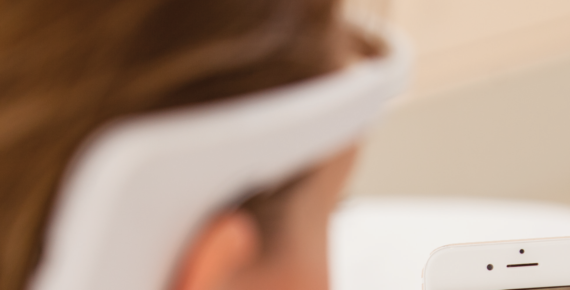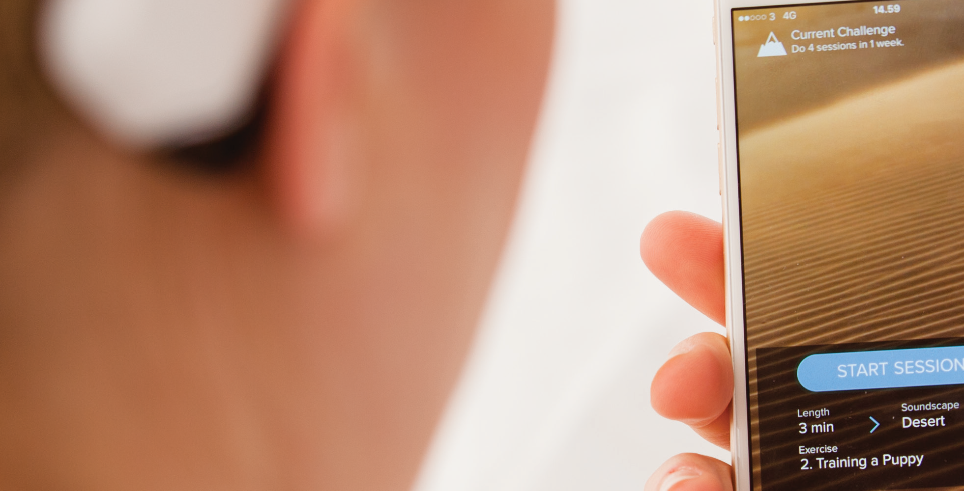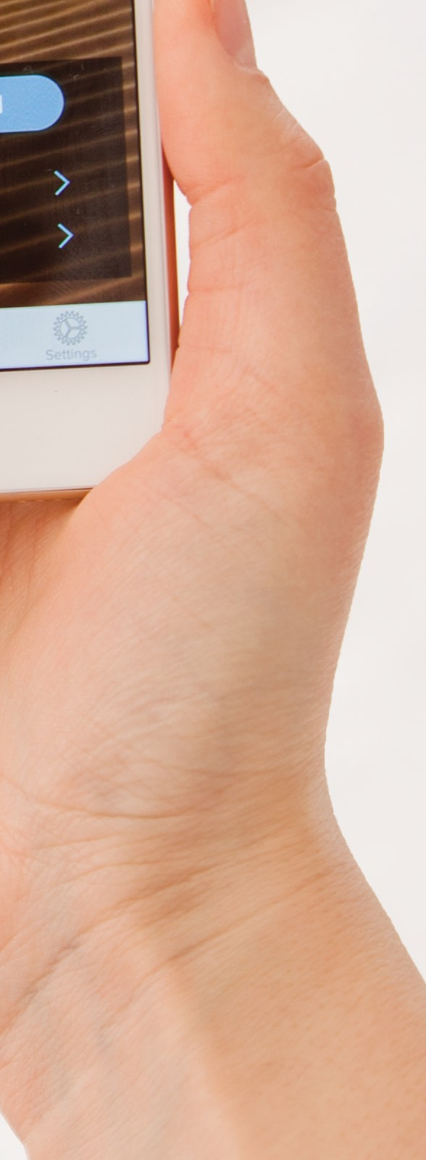

After your session, review your data, set goals, and build a deeply rewarding meditation practice that gets
better every time.

Muse is

Sometimes your mind is calm and sometimes it’s active. Muse will guide you to a calm mind.
Your Personal Meditation Assistant

While you meditate, the headband uses brain-sensing technology to measure whether your mind is calm or active, and translates those signals into guiding sounds.

Start the app, select your meditation length, your lesson and the sound environment you wish to immerse yourself in such as a beach
or a rainforest.

When you’re calm, you’ll hear peaceful weather sounds. When your mind wanders, the weather will intensify, guiding you back to a calm state.

What does Muse Measure?
Your brain is constantly generating electrical signals when you’re thinking, sleeping or even relaxing. These signals can be detected from outside your head, using a technology called Electroencephalogy (EEG).

The Muse headband has 7 finely calibrated sensors – 2 on the forehead, 2 behind the ears and 3 reference sensors – which detect and measure the activity of your brain. This is the same brain sensing technology that doctors and scientists have employed for more than a century to detect your brain signals, similar to how a heart monitor measures your pulse. Muse then sends that feedback to your smartphone or tablet using Bluetooth connectivity.

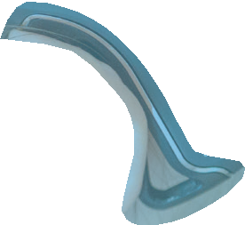

Safe. Trusted. Certified.
More than 120 medical and research institutions around the world have used Muse to help people, including the Mayo Clinic, Harvard University, MIT and the Spaulding Rehabilitation Hospital.

Setting up a Muse Session
Launch the Muse App on an available device, or download from the Apple App or Google Play store.
1

Turn on the headband by pressing the power button (located on the right ear).
2

Muse ﬁts across your forehead just above your eyebrows and behind your ears like a pair of glasses. The headband is adjustable to ensure that the sensors are touching as much skin as possible. Tip: make sure there is no hair between the sensors and your skin especially behind your ears.
3

Launch a Demo Session, or if you have created your own account select your desired soundscape, session length and exercise and press start.
4

Select the model of headband you have depending on the Muse pictured and then select your model number (the last 4 digits of the serial number located in the inner part of the left ear).
5

Put on your headphones.
6

Muse will check for signal quality. When the colors in the wheel turn solid, then the signal is strong. Tip: closing your eyes and taking a deep breath helps Muse connect.
7

Close your eyes. Muse will now calibrate to create a baseline for your meditation.
8

Meditate! Focus on your breathing, and listen to the sounds of the weather. When the sounds intensify it means that you are distracted. Your goal is to identify when your mind begins to wander, re-engage with your breath and quiet the environment.
9

Review your results!
10

choosemuse.com
professionals@choosemuse.com

@choosemuse

